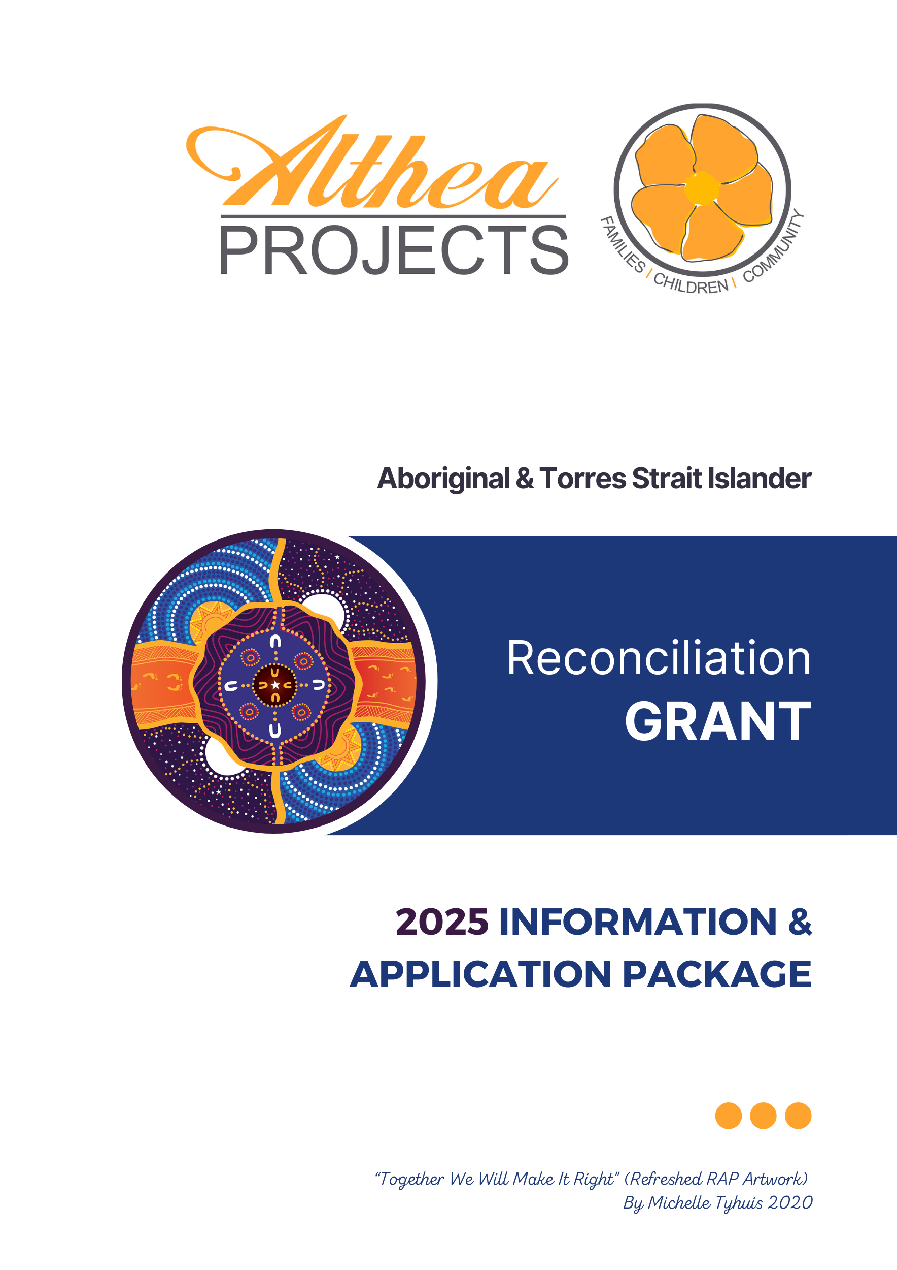

Table of Contents

About Althea Projects 3

Reconciliation & Closing the Gap 4

Althea Projects Aboriginal & Torres Strait Islander Reconciliation Grants 4

What can be applied for? 4

What can’t be applied for? 4

Grant Size 5

Eligibility to Apply 5

Supporting Documentation 5

How to Apply 6

How to Submit your Application 6

Approval Process and Timelines 6

Payment of Funds 6

Frequently Asked Questions 7

Reconciliation Grant Application Form 8

# About Althea Projects

Althea Projects Incorporated (Althea Projects) is a grassroots, community based not for profit service based in Townsville.

From 1974 to present, Althea Projects (formerly known as Wee Care Family Incorporated) has been consistent in our commitment to supporting and strengthening the capacity of vulnerable families, children and young people within Townsville and surrounding regions.

Althea Projects operates from a child centred, family focused, and culturally inclusive framework. Our mission is to support and strength individuals, families, children, and young people so they experience social, emotional, physical, and mental wellbeing and reach their full potential.

Althea Projects values include:

* Human Dignity & Respect
* Fairness & Equity
* Cultural Mindfulness & Diversity
* Accountability & Transparency
* Innovation & Excellence
* Partnership & Collaboration

The following is an overview of the programs Althea Projects delivers:

* **Wee Care** provides emergency 24-hour accommodation, respite care and emergency day care for children from birth to 11 years old when parents/carers are unable to arrange alternative care in a crisis situation, or due to other circumstances. Weekly playgroups are also held to support families in a strength-based, peer-focussed environment.
* **Althea Foster and Kinship Program** is funded to recruit, train, assess and support foster carers and to provide out of home care placements for children and young people in the Townsville, Charters Towers, Hughenden and Burdekin areas.
* **Althea’s Community Hub** provides case management services to the vulnerable and isolated in our community for the purpose of reducing the number of people who are homeless or at risk of becoming homeless, are living in poverty, and/or in crisis. This includes mobile and outreach services; centre-based activities; and services such as emergency relief, information, advice and referral, laundry and shower facilities, and visiting health services. Meals are also provided that are either centre-based, or available for sale to the community through Morehead Meals.
* **Emergency Relief:** Althea Projects offers emergency relief funding to families and individuals experiencing financial crisis. This is offered from Wee Care and Althea’s Community Hub.

# Reconciliation & Closing the Gap

Althea Projects is committed to being a partner in reconciliation. We want to create meaningful opportunities for both Aboriginal and Torres Strait Islander peoples.

Althea Project’s Reconciliation Action Plan (RAP) seeks to contribute to the 5 dimensions of reconciliation within our community. The establishment of a grant for Aboriginal and Torres Strait Islander peoples aims to contribute to the dimension of equality and equity.

Althea Projects RAP can be accessed at the following web address www.altheaprojects.org.au or at the office of Althea Projects should you wish to view it.

# Althea Projects Aboriginal & Torres Strait Islander Reconciliation Grants

Althea Projects is committed to being a part of closing the gap for both equality, and equity of opportunity. Althea Projects welcomes funding applications for those who are experiencing barriers to their advancement, or inclusion to participate in events or activities due to a lack of money.

# What can be applied for?

Some examples of what may be applied for include:

* Textbooks for University
* Laptop required for educational reasons (please check the laptop scheme at your school before applying)
* Sporting fees and uniforms
* Course/training fees
* Uniforms or equipment required for traineeships
* School excursions

Please note, this list is not exhaustive and provides examples only. These are for one off costs rather than ongoing costs.

# What can’t be applied for?

Applications that will not be considered are:

* Costs associated with anyone other than the applicant (e.g. parent/carer)
* Mobile phone costs
* Household items
* Payment of everyday living expenses
* Food or rental costs
* Entertainment costs
* Fuel costs for the family vehicle

Grant Application Round

The opening and closing application times for 2024 are:

|  |  |  |
| --- | --- | --- |
| **Application Open Date** | **Application Closure Date** | **Announcement Date** |
| 13 January 2025 | 14 February 2025 | 14 March 2025 |
| 1 July 2025 | 8 August 2025 | 5 September 2025 |

Applications received outside these timeframes may be considered at the discretion of the decision-making group.

# Grant Size

Althea Projects allocates $10,000 per year to the RAP grant. Each year we receive grant applications that equal much more than what we have available to give. You are welcome to put in an application for any amount of funding, however if successful you may not receive the full amount that you have applied for. For example, you may apply for $750 towards fees for representative sports, however we may approve a payment of $400 as a contribution. This allows us to also make a contribution to other applicants as well.

# Eligibility to Apply

* Applicants who identify as Aboriginal or Torres Strait Islander can apply
* There are no age limits
* Applicants must live in the Townsville and surrounding regions including, Home Hill, Ayr, Charters Towers, Hughenden, Ingham and Palm Island.
* Applicants can be individuals or groups
* Applications must be based upon a funding request that would assist you/your team towards reaching your goals.
* Previously successful applicants may apply again but not within 12 months of having been successful in gaining a grant.

# Supporting Documentation

Without the correct supporting documentation, we will not be able to process your application. The applicant’s name must be listed on the supporting documents. You will need to provide:

* Proof Documentation – e.g. letter from sporting organisation, enrolment documents for a course of study, letter from educational organisation listing a laptop as a requirement with the applicant’s name listed.

**Plus 1** of the following with the applicant’s name listed:

* Tax Invoice - if successful, payment will be made directly to the organisation.
* Receipt - for a purchase that has recently been made.

# How to Apply

* **Application Form** – Please complete the application form that is found at the end of this information package. Ensure you attach all supporting documentation.
* **Under 18** - If the applicant is under 18 years of age please provide contact details for a parent or caregiver.
* **Group Applications** - If the application is for a group, then an individual representative of the group is to make the application rather than the group making individual applications. There is a section on the application form to outline the group/team’s details.

# How to Submit your Application

You can submit your application one of the following ways:

* Email to [ceo@altheaprojects.org.au](mailto:ceo@altheaprojects.org.au)
* Post to Althea Projects, Corporate Office, PO Box 905, Aitkenvale MC 4814.
* Hand deliver to Unit 1, 5-11 Fleming Street, Aitkenvale Qld 4814.

# Approval Process and Timelines

* Applicants will receive notice that their application has been received.
* The applications received will be provided to the members of Althea Projects Reconciliation Action Plan (RAP) working group.
* The applications will be assessed within 4 weeks of the application round closing.
* Approval decisions will be made by the RAP working group.
* Applicants will be advised in writing of the outcome of their application.
* If the application is denied, the reasons for the denial will be provided.

# Payment of Funds

* Where a Tax Invoice has been provided along with the Proof Documents, payment of the approved funds will be made directly to the relevant business.
* Where a Receipt has been provided along with the Proof Documents, the approved funds will be paid into a bank account. The bank account details will be verified by phone.

# Frequently Asked Questions

***If I make an application and I am successful, can I make another application in another round?***

Yes, you can make another application in another round. However, the Eligibility Criteria states that you may not apply within 12 months of having been successful in gaining a grant. These grants are aimed at closing gaps and providing opportunities for people to achieve their goals and reach their potential.

***How long will it be before I know the outcome of my application?***

Each funding round has a stated announcement date that is listed in this document under ‘Grant Application Round’.

***If I am not successful in having my grant application approved, could I apply again at another time?***

Yes, you can apply again in another round. However, we recommend that you read over the eligibility criteria and ensure that you have met it before applying again.

***What if I have questions about the application form, who can I talk to?***

You can contact Althea Projects on 4779 3332 and request to speak to someone about the Application process/form.

***Can I apply to other grants at the same time as I apply for this one?***

Yes, you can apply for other grants. Althea Projects may not be able to provide the total cost that you are applying for therefore you may wish to apply for other grants. However, if you are applying for multiple grants, we ask that you declare these details on the application form.

***Do I have to do anything for this money?***

Other than providing the correct documentation, the grant is not conditional on you having to do anything. We do welcome photos and feedback about what you have achieved through receiving the grant money. However, this has no bearing on the approval decision of your application.

***What if I don’t like completing forms?***

If you don’t like, or have trouble completing forms then you can seek help from a

friend, family member, coach, teacher or anyone you trust to help you. If you don’t feel you have anyone to ask, then you can phone or arrange to attend Althea Projects and someone can assist you complete the form.

***If I am a Foster Carer, am I able to apply on behalf of the foster child/ren in my care?***

Yes, you can apply for an Althea Reconciliation Grant. However, if you are applying for costs that are associated with caring for a child, or meeting the day-to-day costs of caring, then we encourage you to re-evaluate your application and consider if this cost could be covered by any Department of Children, Youth Justice and Multicultural Affairs allowances, e.g. High Support Needs Allowance (HSNA), Complex Support Costs (CSNA) or Child Safety’s Child Related Costs. You will not be excluded from applying, and will be assessed as per our internal process and in line with our eligibility criteria.



**APPLICATION**

**FORM**

# 

# Reconciliation Grant Application Form

|  |  |  |
| --- | --- | --- |
| First Name: | Last name: | |
| Birth Date: | Age: | |
| Is this an individual application or a group/team application? | Individual □ | Group/team □ |
| Are you:  Aboriginal □ Torres Strait Islander □ (or) Aboriginal & Torres Strait Islander □ | | |
| Postal Address: | | |
| Town: | Postcode: | |
| Contact email: | Telephone number: | |
| Only complete this next section if this is a group/team application | | |
| Team Name: | | |
| Type of Group/Team: | List of team members’ names: | |

|  |  |
| --- | --- |
| Amount of funding being requested: | $ |
| Please explain exactly what the funding would be used for: | |
| Please describe/explain how having these funds approved would help you/your team with your goals and/or future aspirations? | |
| Signature: (if under 18, guardian or carer to sign) | Date: |
| **Please Note: You must attach supporting documents or**  **we will not be able to consider your application.** | |

**Only complete this page if you currently have other grant applications in process.**

|  |  |
| --- | --- |
| **Declaration of other grant applications** | |
| What other funding bodies have you made applications with, apart from Althea Projects? (please list these below) | Amounts requested |
|  |  |
|  |  |
|  |  |
|  |  |
| Signature: (if under 18, guardian or carer to sign) | Date: |

You can submit your application one of the following ways:

* + Email to [ceo@altheaprojects.org.au](mailto:ceo@altheaprojects.org.au)
  + Post to Althea Projects, Corporate Office, PO Box 905, Aitkenvale MC 4814
  + Hand Deliver to Unit 1, 5-11 Fleming Street, Aitkenvale, 4814