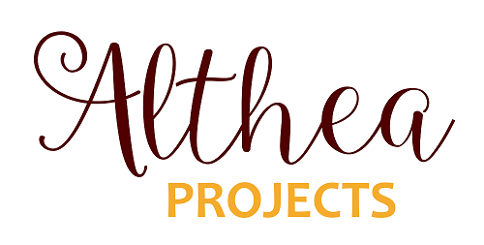
Aboriginal & Torres Strait Islander Reconciliation Grants
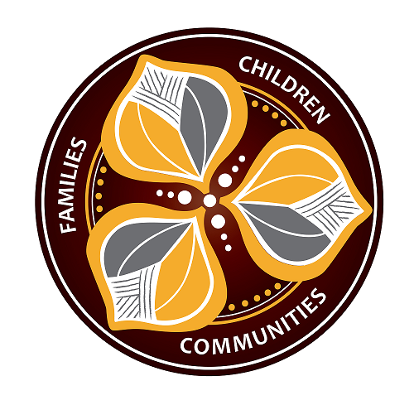
Information & Application
Package 2021

Contents

About Althea Projects 3
Reconciliation & Closing the Gap 4
Althea Projects Aboriginal & Torres Strait Islander Reconciliation Grants 4
Grant application rounds 4
Grant size 5
Eligibility to Apply 5
Application Exclusions 5
Application Process 5
Approval process and timelines 6
Payment of Funds 6
Frequently Asked Questions 6
Application Form 8

About Althea Projects
Althea Projects Incorporated (Althea Projects) is a grass-roots, community based not-for-profit service based in Townsville.
From 1974 to present, Althea Projects (formerly known as Wee Care Family Incorporated) has been consistent in our commitment to supporting and strengthening the capacity of vulnerable families, children and young people within Townsville and surrounding regions.
Althea Projects operates from a child centred family focused and culturally inclusive framework.
Althea Projects mission is to support and strength families, children and young people so they experience social, emotional, physical and mental wellbeing and reach their full potential.
Althea Projects values include;
- Families as it is understood by the individual and their community
- Aboriginal and Torres Strait Islander People, Places and Cultures
- Human Dignity and Respect
- The Principles of Justice and Equity
- Diversity
- Innovation and Excellence
- Partnerships

The following is an overview of the programs Althea Projects delivers:
- Wee Care provides emergency 24-hour accommodation, respite care and emergency day care for children from birth to 11 years old when parents/carers are unable to arrange alternative care in a crisis situation, or due to other circumstances. Weekly playgroups are also held to support families in a strength based, peer focussed environment.
- Shared Family Care is funded to recruit, train, assess and support foster carers and to provide out of home care placements for children and young people in the Townsville, Charters Towers, Hughenden and Burdekin areas.
- The Townsville Drop-in Centre supports people within the community who are experiencing or are at risk of homelessness, are living in poverty, in crisis, or social isolation. Services provided include housing referrals, community and home care, centre-based activities, emergency relief, information and advice, laundry and shower facilities and visiting health services.

- Althea Projects also offers Emergency Relief Funding to families and individuals experiencing financial crisis.

Reconciliation & Closing the Gap
Althea Projects is committed to being a partner in reconciliation. Althea Projects wants to create meaningful opportunities with Aboriginal and Torres Strait Islander peoples.
Althea Projects overall RAP Action Plan seeks to contribute to the 5 dimensions of reconciliation within our community. One such action Althea Projects can do with regard to the dimension of equality and equity is the establishment of Aboriginal and Torres Strait Islander Reconciliation Grants.
Althea Projects Reconciliation Action plan can be accessed at the following web address http://altheaprojects.org.au or at the offices of Althea Projects should you wish to view it.

Althea Projects Aboriginal & Torres Strait Islander Reconciliation Grants
Althea Projects is committed to being a part of closing the gap for both equality and equity of opportunity. Althea Projects welcomes funding applications for those who are experiencing barriers to their advancement or inclusion to participate in events/activities due to a lack of money.
Some examples of what might be applied for with these grant applications are;
- Text books for University
- Laptop required for educational reasons
- Sporting costs
- Course/training fees
- Uniforms or equipment required for traineeships
- School activities
This list is not exhaustive but provides examples of the grants that could be applied for.
These grant applications are for one off costs rather than ongoing costs.

Grant application round
The opening and closing application times for 2021 will be;
Application Open Date | Application Closure Date | Announcement Date
January 4th | February 12th | March 12th
July 5th | August 13th | September 10th

Applications received outside these timeframes may be considered at the discretion of the decision making group.

Grant size
Althea Projects allocates $10,000 per year to grants. Althea Projects aims to provide as many grants as possible per year within this allowance. Given this, applications of up to $1500 will be preferred. If the funding amount you require is larger than this, you can still apply and Althea Projects may approve the total or may approve a portion of what is being requested in which to provide you with some assistance towards your goals.

Eligibility to Apply
- Applicants who identify as Aboriginal or Torres Strait Islander can apply
- There are no age limits
- Applicants must live in the Townsville and surrounding regions including, Home Hill, Ayr, Charter Towers, Hughenden, Ingham and Palm Island.
- Applicants can be individuals or groups
- Applications must be based upon a funding request that would assist you/your team towards reaching your goals.

Application Exclusions
Applications that will not be considered are;
- Updated mobile phone
- Household items
- Payment of everyday living expenses
- Food or rental costs

Application Process
- The application form is at the end of this information package. Ensure the form is completed and attach all supporting documentation for your request.
- Your application can be scanned and emailed to ceo@altheaprojects.org.au, or
- Applications can be posted to Althea Projects, Corporate Office, PO Box 905, Aitkenvale MC 4814, or
- Applications can be hand delivered to Level 1, 296 Ross River Road, Aitkenvale, 4814
- Applicants under 18 years can be assisted by an adult or other person to make their application
- If the application is for a group then an individual representative of the group is to make the application rather than the group making individual applications. There will be section on the application form to outline the group/teams details.

Approval process and timelines
- Applicants will receive notice of receipt that their application has been received.
- The applications received will be provided to the members of Althea Projects Reconciliation Action Plan (RAP) working group.
- The applications will be assessed within 4 weeks of the application round closing.
- Approval decisions will be made by the RAP working group.
- Applicants will be advised in writing of the outcome of their application.
- If the application is denied, the reasons for the denial will be provided.

Payment of Funds
- Payment of approved funds will only be paid on a tax invoice to the relevant business.
- Payments will not be paid into personal bank accounts.

Frequently Asked Questions

If I make an application and I am successful, can I make another application in another round?
Yes, you can make another application in another round. However, go back to the eligibility to apply criteria and check if what you plan to apply for really fits. These grants are aimed at closing gaps and providing opportunities for people to achieve their goals and reach their potential.

Generally how long should it be before I know the outcome of my application?
The funding rounds will have a stated announcement date. This is the date you will know by.

If I am not successful in having my grant application approved, could I apply again at another time?
Yes, you can apply again in another round. But before you do, ensure you go back to the eligibility to apply criteria to ensure your request meets it.

What if I have questions about the application form, who can I talk to?
You can contact Althea Projects on 4779 3332 and request to speak to someone about the Application process/form.

Can I apply to other grants at the same time as I apply for this one?
Yes, you can apply for other grants. Althea Projects may not be able to provide the total costs if they are substantial so Althea Projects would not want to limit you meeting your goals by not considering your application. However, if you are applying for multiple grants, we just ask that you declare these details on the application form.

Do I have to do anything for this money?
The grant is not conditional on you having to do anything. If there was to be something such as a photo opportunity with yourself of your achievement this could only occur by your consent. This would always be sort from you. Your consent or non-consent to this would have no bearing at all on the approval decision of your application.

What if I don’t like completing forms?
If you don’t like or have trouble completing forms then you can seek help from a friend, family member, coach, teacher or anyone you trust to help you. If you don’t feel you have anyone to ask, then you can phone or arrange to attend Althea Projects and someone can complete the form on your behalf from having a verbal conversation with you about it.

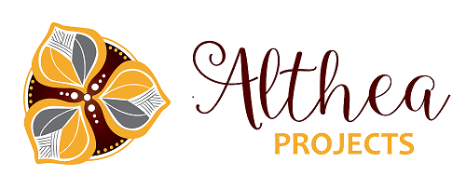

Reconciliation Grant Application Form

First Name: | Last name:
Birth Date: | Age:
Is this an individual application or a group/team application? | Individual | Group/team
Are you:

Aboriginal Torres Strait Islander (or) Aboriginal & Torres Strait Islander
Postal Address:

Town: | Postcode:
Contact email: | Telephone number:
Only complete this next section if this is a group/team application
Team Name:

Type of Group/Team: | List of team members names:

Amount of Funding being requested: | $
Please explain exactly what the funding would be used for:

Please describe/explain how having these funds approved would help you/your team with your goals and/or future aspirations?

Signature: (if under 18, guardian or carer to sign) | Date:
You must attach supporting documents to your application to assist us with our decision making.

Only complete this page if you currently have other grant applications in process.

Declaration of other grant applications

What other funding bodies have you made applications with, apart from Althea Projects; (please list these below) | Amounts requested
Signature: (if under 18, guardian or carer to sign) | Date:

Options for submitting this application:

- Emailing it to ceo@altheaprojects.org.au (please put in the subject line of the email “Reconciliation Funding Grant’

- Posting it to Althea Projects, Corporate Office, PO Box 905, Aitkenvale MC 4814

- Hand delivering it to Level 1, 296 Ross River Road, Aitkenvale, 4814

If required, Althea Projects can be contacted on 4779 3332.

